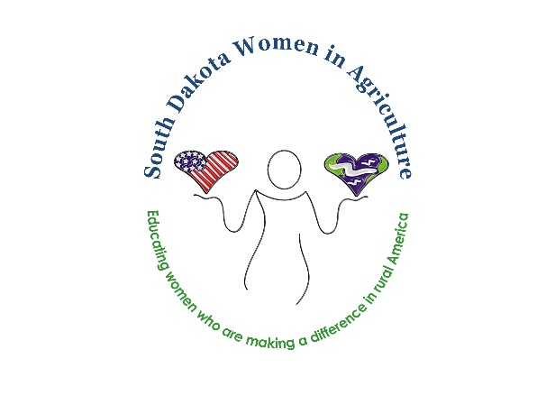
2021 NOMINATION FORM
South Dakota Women in Agriculture
South Dakota Ag Woman of the Year
South Dakota Young Gun of Ag

Your name: ___________________________________________________________________________
Your contact information: _______________________________________________________________
_____________________________________________________________________________________
Who are you nominating? _______________________________________________________________
Which award are you nominating her for? South Dakota Ag Woman of the Year
South Dakota Young-Gun of Ag (25 years old or younger)
Tell us more! Nominee’s hometown:
__________________________________________________________________
Nominee’s family: ______________________________________________________________________
How is she involved in agriculture? ________________________________________________________
How does she exemplify South Dakota Women in Agriculture? __________________________________
_____________________________________________________________________________________
_____________________________________________________________________________________
_____________________________________________________________________________________
How is your nominee active in the ag industry at home, in her community, in the state of South Dakota?
_____________________________________________________________________________________
_____________________________________________________________________________________
_____________________________________________________________________________________
_____________________________________________________________________________________
How does the nominee advocate for agriculture? _____________________________________________
_____________________________________________________________________________________
_____________________________________________________________________________________
_____________________________________________________________________________________
Why do you feel this nominee is the perfect candidate for this award? ____________________________
_____________________________________________________________________________________
_____________________________________________________________________________________
_____________________________________________________________________________________
Please complete and submit this form by September 30, 2021 via email to:
SDWIA AWARDS CHAIR- Amy Pravecek : amy.pravecek@zoetis.com
Each nominee is scored on advocacy, community and youth involvement, and mediums used to share
information and educate about agriculture (i.e. blogs, social media, presentations, etc.). Finalists will be
announced and will earn additional points based on Facebook likes/comments on the SDWIA Facebook
page.

